Testing Report - xcros.in

- Testing Results for Responsiveness:
The website responsiveness was tested across multiple screen sizes and devices to verify content visibility, alignment, and overall user experience.
Issues Identified
- Mobile S – 320px
The upper content is getting cut off and the right-side content is not properly visible. Horizontal scrolling is required to view the side contents.
- Mobile M – 375px
The upper content is getting cut off.
- Mobile L – 425px
The upper content is getting cut off.
- Tablet – 768px
The upper content is hidden till the time bar section.
- Laptop – 1024px
The upper content is hidden.
- 4K – 2560px
The content appears compressed and smaller within the page layout.
- iPhone SE
A small portion of the upper content is not visible.
- Samsung Galaxy S8+
The upper content is slightly hidden.
- iPad Mini
The upper content is slightly hidden.
- Surface Duo
The upper content is slightly hidden.
- Galaxy Z Fold 5
All contents are visible, but horizontal scrolling is required to view the side contents completely.

Working Properly
- Laptop L – 1440px
All contents and sections are displaying correctly.
- iPhone XR
All contents are displaying correctly.
- iPhone 12 Pro
All contents are displaying correctly.
- iPhone 14 Pro Max
All contents are displaying correctly.
- Pixel 7
All contents are displaying correctly.
- Samsung Galaxy S20 Ultra
All contents are displaying correctly.
- iPad Air
All contents are displaying correctly.
- iPad Pro
All contents are displaying correctly.
- Surface Pro 7
All contents are displaying correctly.
- Asus Zenbook Fold
All contents are displaying correctly.
- Samsung Galaxy A51/71
All contents are displaying correctly.
- Nest Hub
All contents are displaying correctly.
- Nest Hub Max
All contents are displaying correctly.

- Front Page Navigation Testing Report
Issues Identified
- The world icon present in the footer is not navigating to the respective page.
- The Privacy and terms link in the footer is not navigating to the next page.

Beta Version Navigation Testing Report
Issues Identified
- The QR code for downloading the application is getting scanned successfully, but the respective page is showing as deactivated.
- In the “Chat with Admin” section, certain buttons are not functioning properly.
Non-Working Buttons:
- Set Up Notifications
- Submit a Ticket
- Knowledge Base
- Video Tutorials
- Reviews
- Forum
- Webinars
- ChatGPT
- AI
- Whiteboard

- Beta Version – User Legal
User Legal – Website Terms and Conditions
Issues Identified
- The Website Terms and Conditions page is displaying raw HTML/code content instead of the properly formatted webpage.
- HTML tags and styles are directly visible on the page.
- The content formatting is broken and not user-friendly.
- The webpage requires proper HTML rendering and formatting fixes.
Displayed Code Content
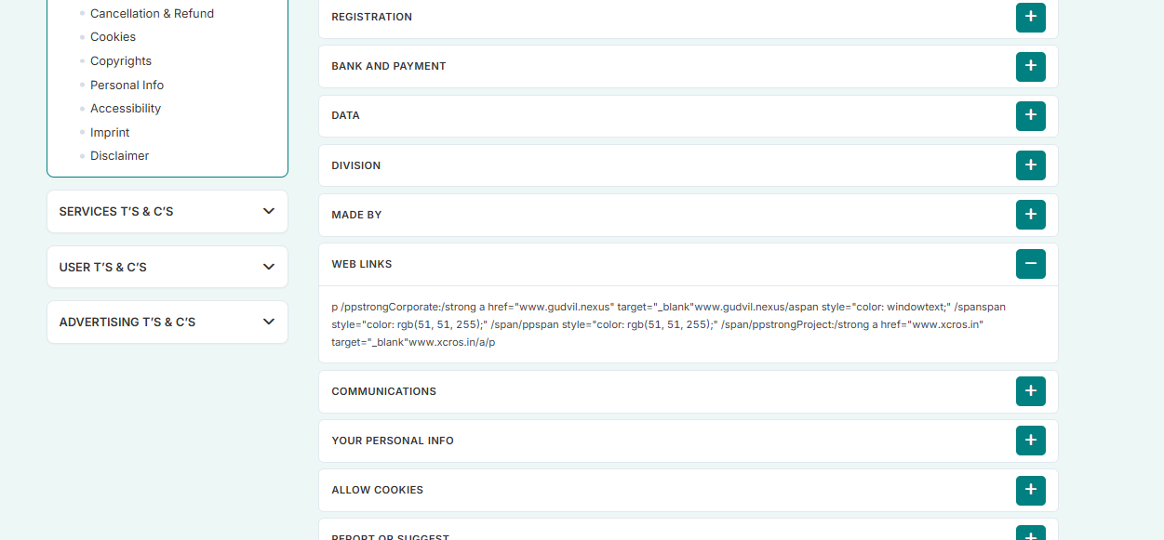
Cookie Preferences – Manage Consent Preferences
Issues Identified
- The consent preference options are not displaying correctly.
- Radio/select buttons are appearing as plain text instead of interactive buttons.
- The UI alignment and formatting are not proper.
- Users are unable to clearly identify the selectable consent options.
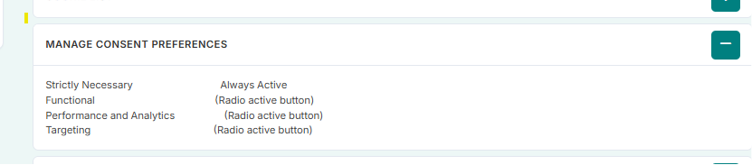
- Beta Version City-wise Testing Report
Chennai
Issues Identified
- Certain Launch Sponsor images are not displaying properly on the Chennai page.
- In the Chennai popup section, the “Contact Us” page is not showing the required information/content.

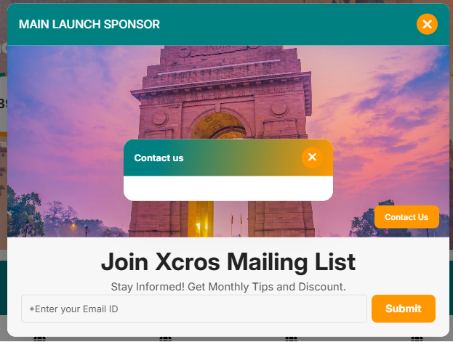

- Beta Version Feature Listings Testing Report
View All Pincodes and view cities:
Issues Identified
- Certain images are not displaying properly in the “View All Pincodes and view cities” section.
Feature Listings – Business Page
Issues Identified
- Some images are not showing properly.
- Certain sort options are not functioning correctly.
- The “Grand Spice Kitchen” image is not displaying properly.
Feature Listings – Professionals
Issues Identified
- Some images are not displaying properly.
- The “Book an Appointment” button is not working.
- The “Grand Spice Kitchen” image is not displaying properly.
Feature Listings – Handyman
Issues Identified
- The “Book an Appointment” button is not navigating to the correct page.
- The “Grand Spice Kitchen” image is not displaying properly.
Explore Popular Category
Categories Tested
- Women’s Fashion
- Sports and Outdoors
- Real Estate
- Jewellery
- Home and Garden
Issues Identified
- The “Grand Spice Kitchen” image is not displaying properly in the above categories.
- In the “Explore Popular Categories” section, the jingle/audio feature is not functioning properly inside the promoted listings restaurant pages.
- The jingle is not playing when accessing individual restaurant pages under each category.
- Audio functionality appears to be inactive or not responding across the promoted restaurant listings.
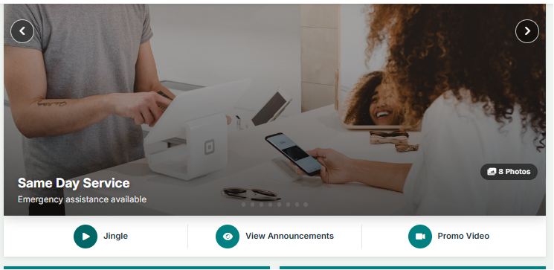

Promoted Category Section
Issues Identified
- The “Grand Spice Kitchen” image is not displaying properly.

- Inside menu Bar
Support – Help Center

    - View by Connect Through Pincode
- While clicking the “Vertical Market” button, it is navigating to the “Choose Service” page instead of the intended “Vertical Markets” page.
- Incorrect page redirection is occurring for the Vertical Market navigation option.

    - Gallery Section
- The “Add” button is not functioning properly.
- Images are not displaying correctly in the Gallery section.
- Gallery content loading requires fixes.

    - Help Line Section
- The “Get Directions” button is not working.
- Navigation/redirection for directions is not functioning properly.

- Support – View Profile Testing Report
Navigation Path
Menu Bar → Support → Help Center→ View Profile

Reviews Section
- Images in the Reviews section are not displaying properly.
- Certain review-related images are missing or not loading correctly.
Service Agents Section
- Service agent images are not showing properly.
- Image loading/display issues are present in the Service Agents section.
Advertisement Section
- The carousel in the Advertisement section is not functioning properly.
- Carousel sliding/navigation is not working as expected.

- Service Market Place Testing Report
Navigation Path
Menu Bar → Support → Help Center → Service Market Place
Search Settings
- The dropdown option in the Search Settings section is not functioning properly.
- Dropdown items are not opening/selectable when clicked.
- Search filter functionality is affected due to the non-working dropdown.

- Stores Section Testing Report

Navigation Path
Menu Bar → Support → Help Center → Service Market Place → Stores

Filters Section
- The Price Range filter is not functioning properly.
- Users are unable to filter store listings based on price range selection.
- Filter functionality is not responding as expected.

Advertisement Section
- Advertisement images are not displaying properly.
- Certain advertisement images are missing or not loading correctly.

- Careers Page Testing Report
Explore Opportunities
- The “Explore Opportunities” button is not navigating to the respective page.
- Page redirection is not functioning properly.
Gudvil-Nexus → Services
- The “Services” option under Gudvil-Nexus is not navigating properly.
- Clicking the link does not redirect to the intended page.
Get Social
- The “Get Social” section is displaying a blank page.
- Content is not loading properly in the section.
- Expo Calendar Button
- The “Expo Calendar” button is not functioning properly.
- Clicking the button does not navigate to the respective page.
- Page redirection for the Expo Calendar option is not working.

- Conclusion
Certain images are not displaying properly across multiple pages and sections of the XCROS.IN website, including feature listings, advertisements, promoted categories, gallery sections, reviews, and service agent pages.

